CELTA Application Form
Please insert photo here.
Please select the course that you are interested in:
Course date 1st Choice:
Course date 2nd Choice (if applicable):

Personal Details:

Surname: |  | First name:
Date of birth: |  | Gender:
Phone: |  | First Language(s):
Skype: |  | Nationality:
Present Occupation: |  | General health:
Email:
Address:

How did you hear about CELTA at Language Link China? Please state which website if applicable.

Education
Please give name of qualification, name of institution, grades attained and year of completion:
Institution, qualifications, and dates
Secondary/High
School
Further/Higher
Education
Qualifications Connected to teaching

Language Proficiency:
Please indicate your first language(s). Indicate any languages other than English that you have knowledge of. Indicate spoken / written competence.
Mother Language(s): |  | Languages other than English:

Relevant Work Experience
Please write a summary paragraph about any work or people experience relevant to teaching. Write in continuous prose (100 words or less):

Teaching experience (if any)
Indicate English Language Teaching Experience where applicable. Please give details of schools, dates, and type of teaching. (e.g. adults, young learners)
Name of Institution | Dates | Young Learners or Adults?

Are you currently working as a teacher? Yes/No:

Please give reasons for doing the course. How do you think this course will be valuable to your career in language teaching? Please write in continuous prose, not in note form (100-150 words):

Special Needs
In line with Cambridge ESOL Teaching Awards’ Equal Opportunities Policy, Language Link China will make every effort to accommodate applicants with special requirements. Applicants with special requirements should be able to confirm that they have the necessary strategies and/or the personal and technical support to enable them to complete the course successfully. Language Link China will make reasonable adjustments to the course programme and course delivery where necessary, and accepts their responsibilities in relation to legal requirements.
The centre is required to confirm with Cambridge ESOL any special arrangements before accepting the candidate onto the course.
If you have special requirements you are encouraged to familiarise yourself with the role of the teacher and the demands of the classroom in the field of ELT before accepting a place on the course. This can be through discussions with course tutors and visiting the centre beforehand.

Do you have any medical conditions or personal circumstances that would affect your ability to complete the course?
Yes/No:
If yes, please specify:

Declaration

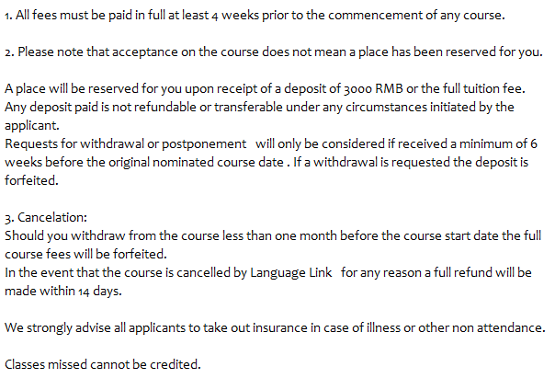

I have read and understood the conditions of application, and agree to abide by them. I also confirm the following:
- this completed application form is entirely my own work.
- all the personal and professional information given in the form is true.
- I personally will be undertaking the face-to-face or telephone/Skype interview.

Signed:
Date:

Please send the completed application and a passport sized photograph to:ash@languagelink.com.cnor mail to:
Language LinkChinaTeacher Training Department
709 Inter-China Building, 33 Dengshikou Street,
Dongcheng District, Beijing 100006China
Tel: 86-10-51695583 Fax: 86-10-65280954

PRE INTERVIEW TASK

Complete this task carefully. It is one of the factors we consider when making a decision about your application. Please make a copy of this task so that you may refer to it during the interview

This task is designed to help us assess your ability to think about and research language. We recommend you use grammar reference books such as the ones listed below to help you:

English Grammar in Use by Raymond Murphy (CUP)
Practical English Usage by Michael Swan (OUP)
How English Works by Michael Swan & Catherine Walter (OUP)

1. Language awareness
Below are four sections containing two pieces of language. Focusing on the underlined parts:
- Describe the differences in meaning
- Explain how you might clarify this to someone learning English.

The first one has been done for you.

- He’s slim.
He’s thin.
1. What are the differences in meaning?
“Slim” is related to an ideal body shape, or a polite reference to it. A slim person does not have too much fat on their body. “Thin” describes somebody who has less body fat than a healthy person. It has a negative connotation, indicating that somebody is perhaps not healthy.
2. Explain how you might clarify this to someone learning English.
To clarify the differences I could set a clear context, perhaps a situational presentation at the board. Visuals will certainly be useful.
- I’ve lived in Beijing for 10 years
I lived in Beijing for 10 years.
1. What are the differences in meaning?
2. Explain how you might clarify this to someone learning English.

- They’ve gone to Olympic Park.
They’ve been to Olympic Park.
1. What are the differences in meaning?

2. Explain how you might clarify this to someone learning English.

- She should go to the Great Wall.
She should be at the Great Wall by now.
1. What are the differences in meaning?

2. Explain how you might clarify this to someone learning English.

2. Learner Errors

Look at the verbs underlined in the following sentences. In each:
- Correct the sentence.
- Name the correct verb form / tense.
- State why the correction was needed.

*The first one has been done for you.

1. I read a book at the moment.
a. I'm reading a book at the moment
b. Present Continuous
c. ‘At the moment’ emphasizes an action happening now, rather than a permanent
state, habit or routine.

2. I am speak a lot of English these days.
a.
b.
c.

3. Can you come for a drink tonight?

Sorry, I'll go to see Hamlet at the National Theatre.
a.
b.
c.

4. At the station I realised I left the tickets at home.
a.
b.
c.

3Pronunciation Considerations

①Indicate the main stress in each of the words below using an apostrophe as it would feature in a dictionary.
②Divide the word into syllables. How many syllables are there in the pronunciation of each word at natural speed?
③Research the “schwa” sound and its phonemic symbol. Find the symbol for the “schwa” and then cut and paste it into the appropriate sections of the word blow.

- comfortable (adjective)
①
②
③

- photographer (noun)
①
②
③

- record (verb)
①
②
③

- diligently (adverb)
①
②
③

- vegetable (noun)
①
②
③

- American (adjective)
①
②
③

- In the Classroom (you can complete the following two writings in a separate word file)
- With reference to your own learning experience, what do you consider to be the most important factors that aid learning in a classroom? Write in continuous prose (250 words):

- Research information about the CELTA course on the internet and identify two strengths and two weaknesses you may have when doing this course. What concrete strategies will you use to ensure that you will be successful on the course? Write in continuous prose (200-250 words):

Note: This application is a test of your ability to follow instructions, access reference materials and write English to a suitable standard for the course. Don’t be surprised if you have to resubmit this application if it hasn’t been completed to a high standard.

